SUNDON PARK BAPTIST CHURCH
THE BEACON PROJECT

The Project
The Beacon Project is the outreach arm of Sundon Park Baptist Church and is intended to foster links with the local community and to provide support for worthwhile local initiatives, with the overall aim of increasing the social capital of Sundon Park and promoting wholeness of body, mind, and spirit.

Part of that aim involves the replacement of existing, rather tired, buildings with facilities that are fit for purpose. Phase 1 of this programme – The Newns Building (named in memory of Gill Newns who played a major part in getting the Project off the ground) - is now complete and available for use.

The Newns Building
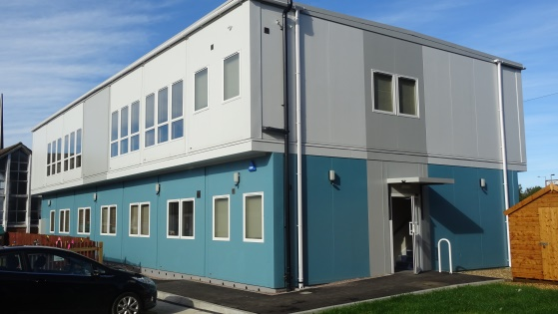
Consists of a two storey building: first floor hall (served by a platform lift and two staircases) with disabled and unisex toilets. Ground floor office, kitchen, four small and two large meeting rooms, disabled and unisex toilets. Both stairwells are 1 hour fire rated, the building is air-conditioned and most areas served by automatic lighting (the hall lighting is switched). Disabled access is via the main auto door and platform lift to the first floor.

Current activities (both Church and independently run) include a Children’s Nursery (Bizzie Bees), Short-Mat Bowls, Tots on Tuesdays, Rhyme Time (both for Mums and Tots), Beacon Groups, Keep Fit, Slimming World, Singing Café, as well as the usual Sunday Services and other Church Events. Our Church building is used by another Church on a Sunday afternoon and the Hall is let for mainly weekend events (children’s parties, wedding receptions and the like).

Based on word of mouth only, income from these sources has risen to cover the bulk of our running costs for the buildings, notably servicing a Baptist Union loan. We expect to pass break-even point during the next six months. As Christians we look to God to provide what is necessary and have not been disappointed!

If you need a space for a family or group event or need regular accommodation for your activity we would be happy to talk over how we might be able to help. If you would just like to see the Newns Building (situated behind the Church) do ask, we’d be glad to show you round.

What of the Future?
Perhaps you are involved in working with the community or have ideas as to what new facilities or activities Sundon Park needs. If so, we would like to hear from you. We are open to new ways of serving local people. We believe that God has inspired this vision for Sundon Park and we expect great things to result from it.

Contact details

Graham Sturdy (or any of the Trustees) by phone (07843 114130/07504 729597) or email to graham.sturdy@ntlworld.com
Office No. (not staffed full time so there may be a delay in responding) 01582 528691.

Preparations for a Wedding Reception
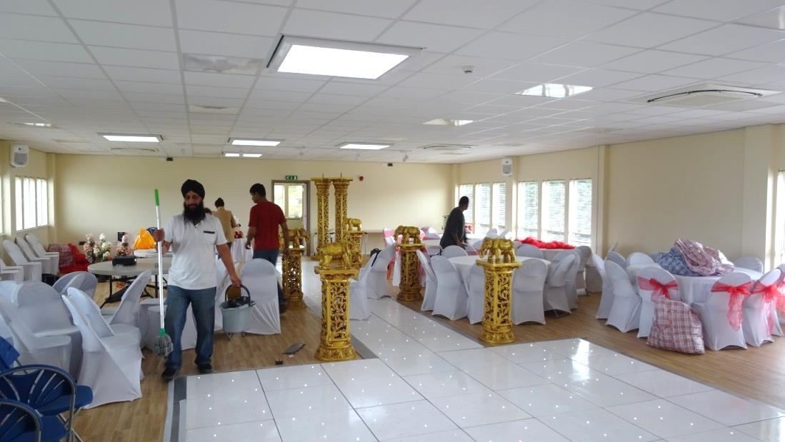

and for Church events 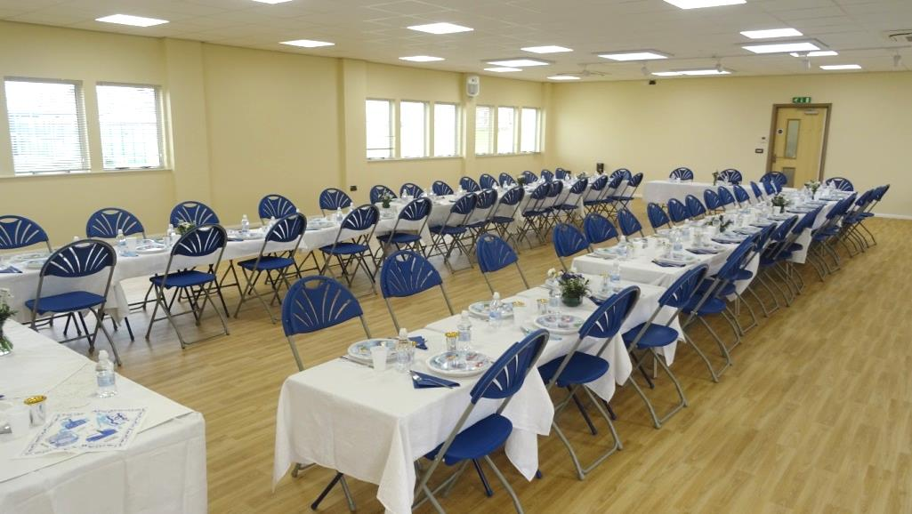

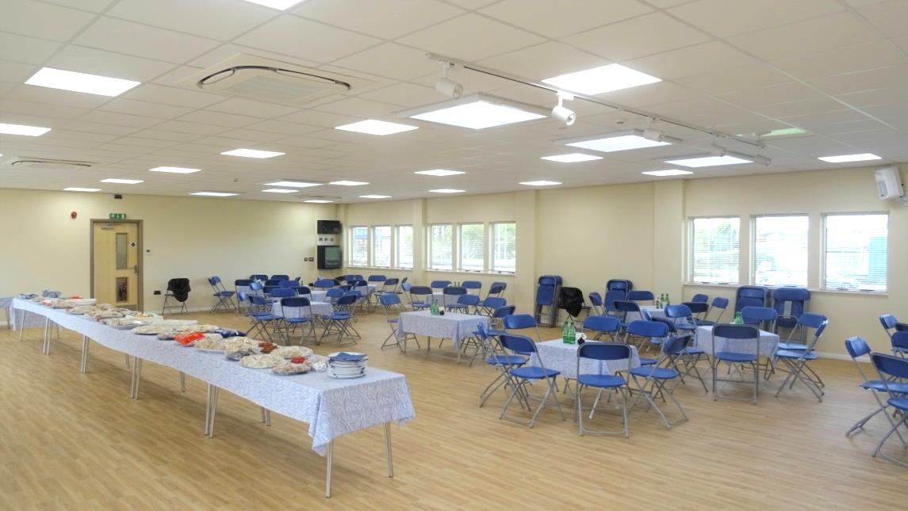

One of the Meeting Rooms (all air conditioned)
